GOVERNMENT DEGREE COLLEGE, GUMMALAKSHMIPURAM
DEPARTMENT OF HISTORY 2024-25
Name of the Event: Tanguturi Prakasam Pantulu
Guest of Honor : D. Ramaiah (Vice - Principal)
Date : 23-08-2024
Department : History
Lecturers Attended: 10
Students Attended: 50
The department of History of Government Degree College, Gummalakshmipuram, Parvathipuram manyam Dist, conducted the Birth Anniversary Day of Sri Tanguturi Prakasam Pantulu under the presidency of Sri D. Ramaiah Garu , Vice principal . On the account of this day.
The main aim of conducting the event in the college is to make the students participate in the event so that they will share their knowledge about the veteran, Prakasam Panthulu who was a great politician of renown and worked as first Chief Minister of Andhra Pradesh. Every one of us remembered about the works & the greatness of Tanguturi Praksam Panthulu Garu. His braveness during the freedom struggle and intelligence inspired many of the students. We also remembered his sacrifices for the Andhra Pradesh state formation. The event showed the positive impact on the students.
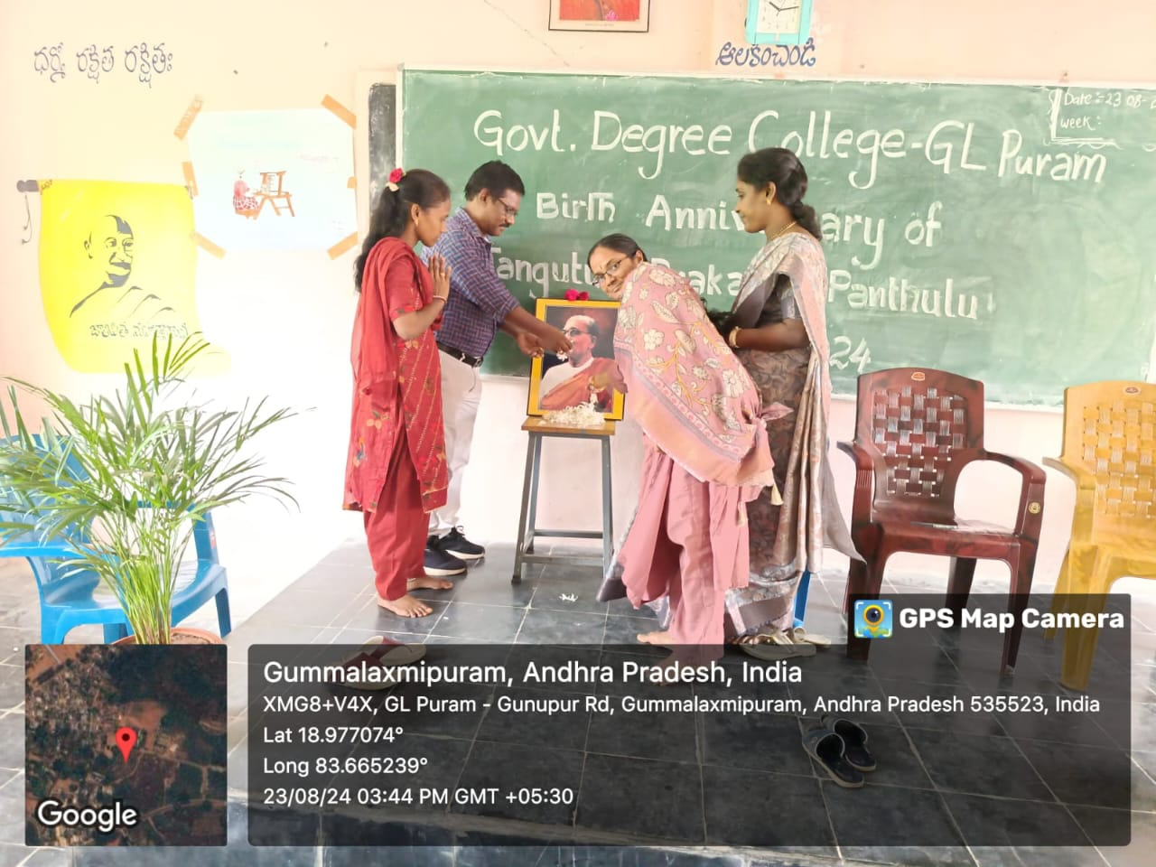
Speech given by Lecturer in History A. Srivani
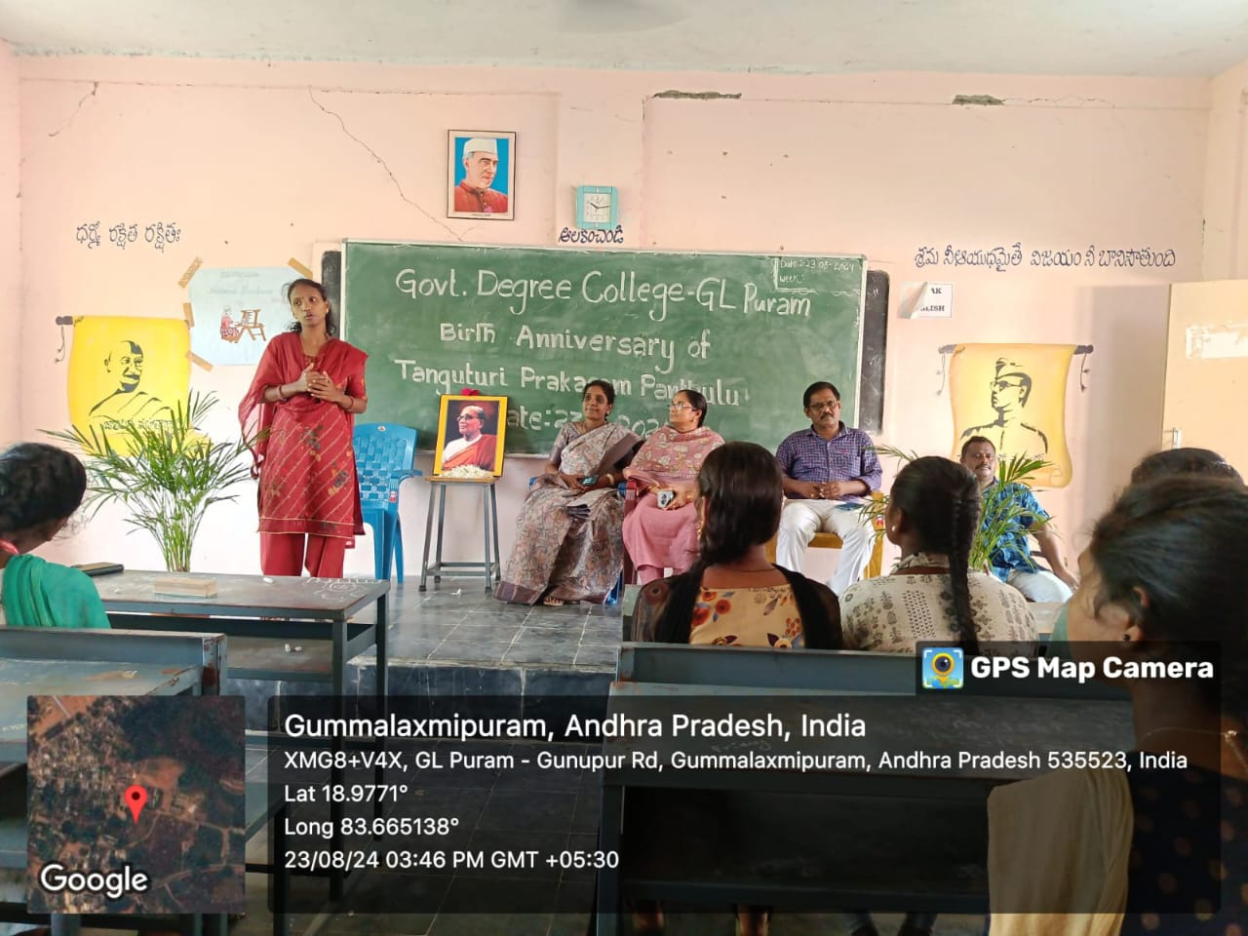
Speech given by P. Jagadeesh

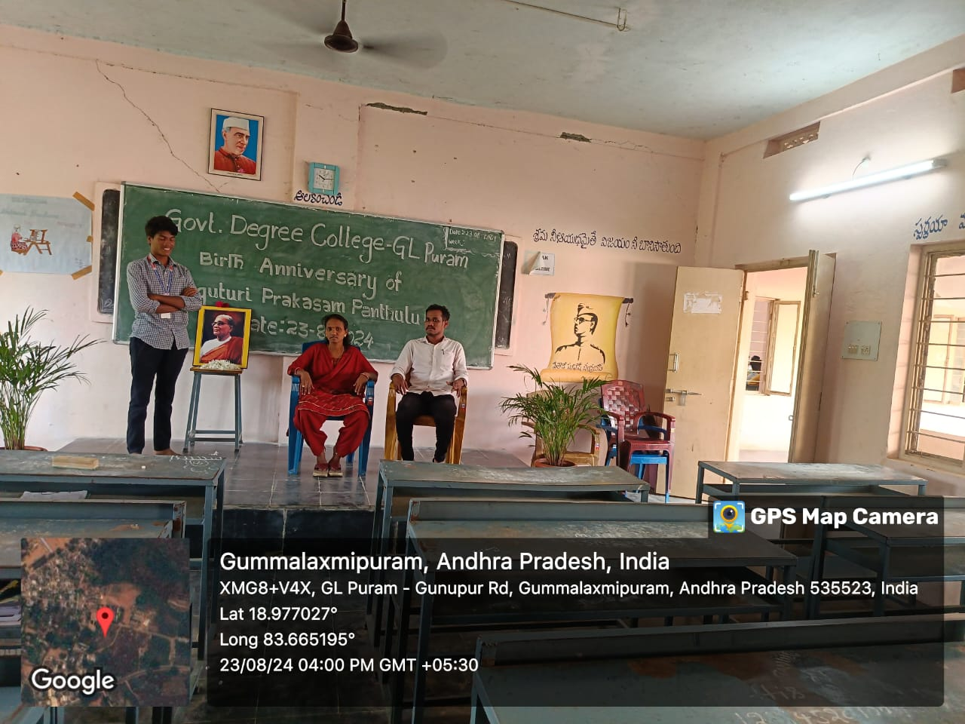
Speech given by A. Sravani
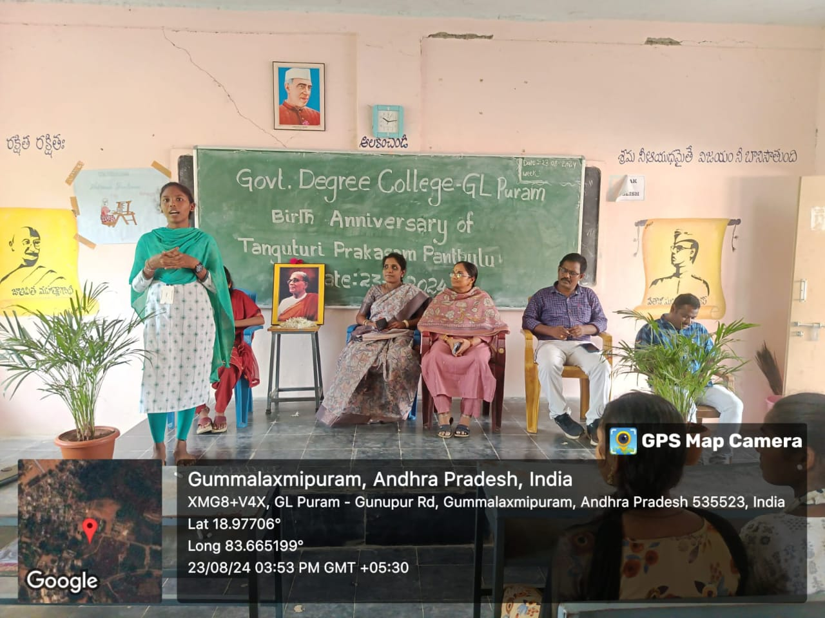
Conclusion: Tanguturi Prakasam Pantulu was a true patriot, a fearless leader, and a champion of justice. His dedication to India’s freedom struggle and his contributions as the first Chief Minister of Andhra Pradesh continues to inspire generations. His unwavering courage, selfless service, and commitment to the people make him a shining example of leadership and sacrifice. As we remember his legacy, let us strive to uphold the values he stood for—truth, integrity, and service to the nation. By following in his footsteps, we can contribute to a better society and honor his vision for a strong and independent India.
Thank you.

